|  |
| --- |
| Software Development Team |
| Let’s Quiz |
| Architecture |

|  |
| --- |
| Aaron Peachey |

Contents

1 Purpose 1

2 Architectural Goals and Philosophies 1

2.1 Usability 1

2.2 Reliability 1

2.3 Performance 2

2.4 Maintainability 2

3 Assumptions and Dependencies 2

3.1 Assumptions 2

3.2 Dependencies 2

4 Architecturally Significant Requirements 2

4.1 Functional Requirements 2

4.2 Architecture Realisation 3

5 Decisions, Constraints & Justifications 3

5.1 Decisions 3

5.2 Constraints 3

5.3 Justifications 3

6 Architectural Mechanisms 4

6.1 Play Game 4

6.1.1 Single Player 4

6.1.2 Multiplayer 4

6.2 Submit Question 4

6.3 Social Media Integration 5

6.3.1 Facebook 5

6.4 GUI 5

7 Layers or Architectural Framework 5

8 Architectural Views 5

8.1 Use Case Descriptions 5

8.1.1 Use Case: End Goal: Register 5

8.1.2 Use Case: End Goal: Login 5

8.1.3 Use Case: Login Registered Users – Sub-Function: End Goal: Login 5

8.1.4 Use Case: Login with Facebook – Sub-Function: End Goal: Login 5

8.1.5 Use Case: Play as Guest – Sub-Function: End Goal: Login 6

8.1.6 Use Case: End Goal: User Submit Question 6

8.1.7 Use Case: End Goal: Start A Game 6

8.1.8 Use Case: Choose Game Mode – Sub-Function: End Goal: Start A Game 6

8.1.9 Use Case: End Goal: Answer Question 6

8.1.10 Use Case: End Goal: Check Leader Board 6

8.1.11 Use Case: End Goal: Submit Score 6

8.2 Full Use Came Diagram 7

8.3 Activity Diagrams 7

8.3.1 Register 7

8.3.2 Login 8

8.3.3 Start Game 8

8.3.4 Answer Question 9

8.3.5 Play Round 9

8.4 Domain Model 10

8.5 Logical View 10

8.5.1 Important Classes 10

8.6 Deployment Diagram 11

9 Implementation of CCRD 11

9.1 Implementation 11

9.1.1 Register 11

9.1.2 Login 11

9.1.3 Answer Question 12

9.1.4 Submit Score 12

# Purpose

This document outlines the overall architecturally significant requirements for this project. Based upon the main NFR’s and the system assumptions/dependencies this document will justify the decisions made and the constraints that come with them. It will also show the overall system view in many forms including class diagrams, activity diagrams and deployment diagram. Basic architectural frameworks are also mentioned to aid in visualizing how this project will be implemented.

# Architectural Goals and Philosophies

The application we wish to develop, as found in the vision document, is a text-based trivia game. The difference between our game to others on the market already, is Let’s Quiz will be targeted towards specific topics and genres. These would be based around Science Fiction and Fantasy and will try to encapsulate that specific demographic of people. The game will be multiplayer, have live leaderboards and supply push notifications to the user.

In order to support multiplayer, we will use a MySQL database to store user, game and question data that will be updated at the end of each round. Firebase will be used to monitor updates to the database and update game data for clients.

The game will be delivered to the Google Play store, opening it up to a wide demographic of people. A iOS version will also be developed but this will not be placed on the Apple App Store by the end of this project.

The intent of Let’s Quiz will be to have two players play online in a multiple choice quiz game against each other. As well as having a global leaderboard and a multitude of available questions. The game will determine a winner and then update their individual high score, player stats and worldwide leader board. The game also allows players to be a part of multiple games simultaneously, allowing players to start new games or continue existing ones. Additionally, users will be able to play in a single player version of this game.

Based on the overall goals set out in the vision document the following are the high priority Non Functional Requirements (NFR’s). Usability, Reliability, Performance and Maintainability.

## Usability

Usability is the most important NFR as without a usable system all other NFR’s can’t even be considered. The game is intended to be run on mobile devices and have a UI catered to those users. The game must be intuitive and self-explanatory in all degrees of operation.

## Reliability

Reliability is important as the majority of the game runs from the server. In order to complete multi-player games a connection to the server is required. Without a reliable connection, users will not be able to complete multi-player functionality.

## Performance

Performance is still important regarding this being a mobile application. The app must be tailored to mobile use and be quick to respond to inputs from the user. It must also have quick response times from the server as delays longer than 1-2 seconds is enough for mobile users to stop using the application. Mobile users expect everything to happen instantly.

## Maintainability

Maintainability is important as the game must be able to be continued to be upgraded and bugs fixed without hindering the overall functionality of the game. Without being maintainable users could experience large downtimes. By focusing on making the game maintainable the server can be kept up for as much time as possible.

# Assumptions and Dependencies

## Assumptions

* There are no current assumptions in the game.

## Dependencies

* AN internet connection is required the first time the game is run, to download the question data. It is also needed at run time in order to play multiplayer games and upload the results back to the database. The user will also not be updated with push notifications if there is no internet connection.
* We are depending quite heavily on the availability of the server. If the server is unavailable at the end of a turn, then multiplayer will not function as intended. A backup system is in place to upload game data once an internet connection is made. In saying this our server provider boasts a close to 100% up time. Users can also play in single player mode if the database is unavailable.
* Our project has a vast amount of different technologies in play including, Unity, C#, PHP, MySQL and Facebook. We are depending on our team members to deliver on their promises to learn how to use and create services using these technologies. To limit risk, we will deliver Technical Competency Applications to prove we can use required technologies.

# Architecturally Significant Requirements

## Functional Requirements

1. The game developed using C# inside Unity and MonoDevelop.

2. The game must be playable on Android devices.

3. The game must receive user, question and game data from a server.

4. The game must update the server with game and user data.

5. The game must be able to generate leaderboards based on data in the server

6. The game must allow users to log in as a guest, Let’s Quiz and Facebook account.

7. The game must allow users to submit questions to the server

## Architecture Realisation

Necessary Requirements for Architecture Realization:

* A log in screen allowing users to register an account, sign in with Facebook, a Let’s Quiz account or skip and play as gust. SDK’s will be used to implement the Facebook service which will provide the application with necessary user data to log them in.
* Once a multiplayer game has been created a connection to the FTP server must be established. If no connection possible the device will try again later, notifying the user. The server must also be updated at the conclusion of each round.
* Each time the game is loaded the app will download the latest question pool and store locally on the phone for offline redundancy.
* An option for the users to submit their own questions to be added to the main question pool used by the game. Subsequently users will have options to vote on given in game questions, if a question reaches a certain number of down votes it is removed from the pool.
* All logic inside the application must be complete. The game must be able to determine correct answers, calculate scores, determine game winners and display the correct answers at the end of game.

# Decisions, Constraints & Justifications

## Decisions

* We will use Unity as our development environment.
* We will allow users to log in using either a Let’s Quiz account or their existing Facebook account. Additionally, they can choose to not log in and play as guess.
* The game will be targeted towards Android mobile users.
* A server will host a MySQL database for storing all game, user and question data.

## Constraints

* An internet connection is required for many functions of the game including, log in, register, downloading questions, updating score to database, viewing leaderboards and submitting questions.
* All of our code will be done using C# and PHP.
* The database will be a MySQL database.
* The user interface will have different levels of authentication handled by separate SDK’s.

## Justifications

We are using Unity as our development environment as it is a program that all team members have used before and it is a suitable program for meeting the other decisions made. Unity allows us to create a cross platform application for Android and iOS. Although we are not delivering to the iOS store, this ability is still important. It is also an environment suitable for game development.

By allowing users to log in using Facebook users can authenticate themselves quickly and using services they are familiar. Users may feel safer doing this rather than signing up directly with our server. A guest option is also available.

None of the architecture being used is specific for either Android or iOS so we are able to develop the same application for both devices.

We do not require users to join a lobby in order to allow multiplayer functionality. Rather the user plays locally for most of the gameplay except when it comes to updating a current round at its beginning and end. Therefore, we can use a MySQL server that just gets updated with current game information as required. This saves significant resources and skill requirements to allow multiplayer functionality.

To allow this form of multiplayer capability the user is required to have an internet connection. However as stated above this internet connection does not need to be consistent but just once at the beginning and end of a round. We will also require functionality to store data that needs to be sent to the server if for some reason an internet connection is not available when required.

Inside of Unity we will use the language of C# to code our application. We need to specify a language to be used and we have chosen this off of the skills of the team members. C# is also the default language of Unity and gives plenty of online support. PHP will be used to communicate commands from the user to the server for the same reason.

Similar to above we have chosen to use a MySQL server due to the fact that team members all have previous experience in implementing and because it is well supported, cheaply available and compatible with PHP.

We require authentication of all users entering into a multiplayer game. This can be done using a guest account, however Facebook or a Let’s Quiz account can also be used.

It is known that all team members have many other commitments over the course of this project. All of these constraints have been laid out in the Team Charter. Team members will be held to their promise of time commitment, if not then action will be taken.

# Architectural Mechanisms

## Play Game

Two options from this button push. The user can either start a new game or select from an ongoing one. Both options require a connection to the internet.

### Single Player

Single Player refers to offline gameplay not requiring an internet connection and playing a game simply for practice and not competing against any other player or bot.

### Multiplayer

Multiplayer refers to the online gameplay where players play games against other real players.

## Submit Question

Users will be able to submit their own questions to become part of the normal game question rotation.

## Social Media Integration

### Facebook

Facebook integration refers to the players Facebook accounts linking to the Let’s Quiz game and accessing certain personal data for registration as well as then playing games against other friends.

## GUI

We will use Unity to design the GUI for display on mobile devices. Will follow standard design principles and not be too dissimilar to other applications of the same nature.

# Layers or Architectural Framework

The majority of the application will follow a mobile architecture pattern. Meaning it will be designed specifically for mobile. The GUI will be relevant and use touch input to move through the application. The application will also be optimized to run on a mobile device.

The application will use a server-oriented architecture model. This model describes application components connecting together through a communication protocol over a wireless network.

# Architectural Views

## Use Case Descriptions

### Use Case: End Goal: Register

When the user

Wants to register a Let’s Quiz account, they must input user details and click register

So that the application creates an account for them

### Use Case: End Goal: Login

When the user

Wants to login, they must choose login option

So that that the application allows login and displays pregame screen

### Use Case: Login Registered Users – Sub-Function: End Goal: Login

When the user

Wants to play by logging in, they then press login

So that that the application opens to the login screen

### Use Case: Login with Facebook – Sub-Function: End Goal: Login

When the user

Wants to play by logging in with Facebook, they then press Facebook login

So that that the application connects to the Facebook Authentication server and allows login

### Use Case: Play as Guest – Sub-Function: End Goal: Login

When the user

Wants to play without logging in or first registering they press play as guest

So that the application opens to the pre-game screen

### Use Case: End Goal: User Submit Question

When the user

Wants to submit a question they will press the submit question button

So that the application opens to the submit question scene

### Use Case: End Goal: Start A Game

When the user

Wants to start a new game they will press the start new game button

So that the application will either start a new game or join an existing game.

### Use Case: Choose Game Mode – Sub-Function: End Goal: Start A Game

When the user

Wants to take their turn in a previously started game they press the games description

So that the application opens the correct game state

### Use Case: End Goal: Answer Question

When the user

Wants to answer a question they select the correct answer

So that the game can check the answer for correctness

### Use Case: End Goal: Check Leader Board

When the user

Wants to check the leader board scores they press the leader board button

So that the application connects to the database and updates the tables

### Use Case: End Goal: Submit Score

When the system

Wants to submit score, the system connects to Let’s Quiz Server

So the application can send score data to data base for updating

### Use Case-Voting

When the user

Wants to vote on a question to the Let’s Quiz question pool

They select a like/dislike button from the question page

So that the application will add or subtract their vote.

### Use Case-Choose a category

When the user

Wants to choose a category

They select a category from the dropdown menu

So that the application will allocate a category.

### Use Case: End Goal: Exit application

When the user

Wants to exit the application they press the back button on android . So that the application closes down

## Full Use Came Diagram

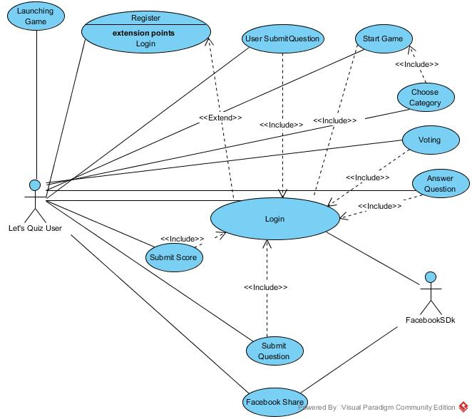

## Activity Diagrams

### Register

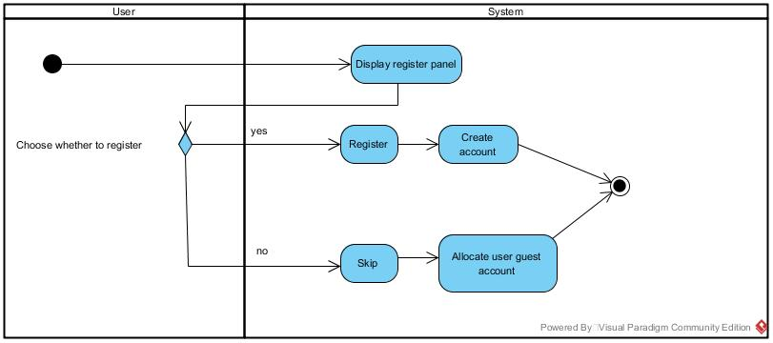

### Login

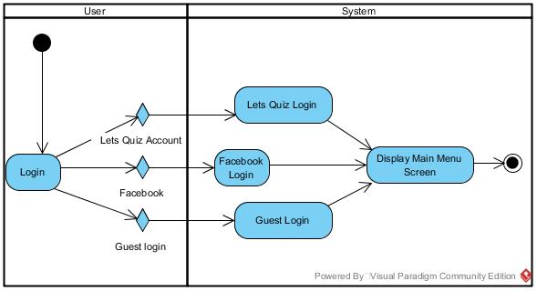

### Start Game

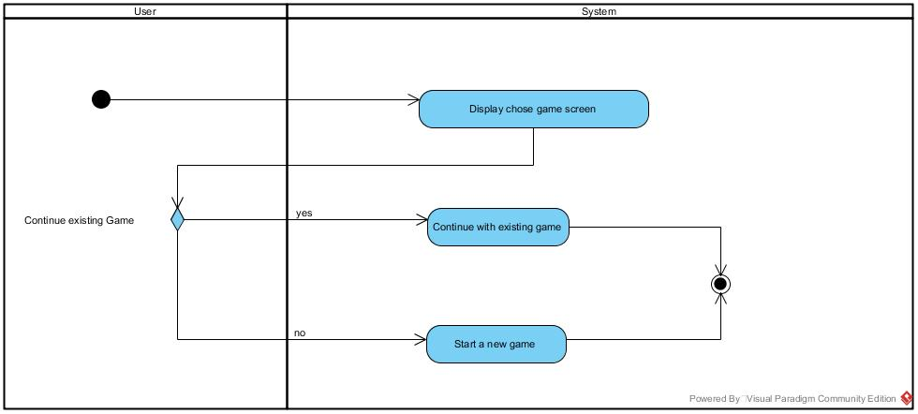

### Answer Question

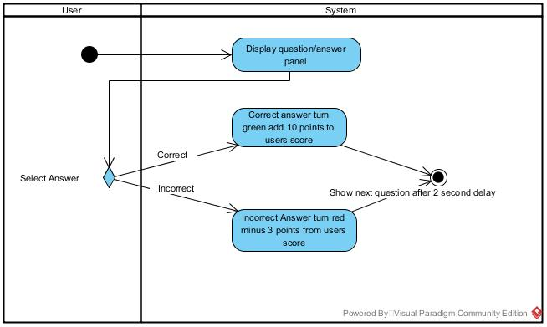

### Play Round

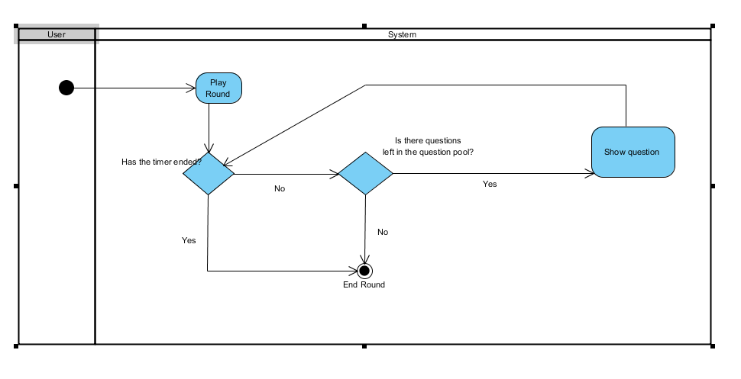

## Domain Model

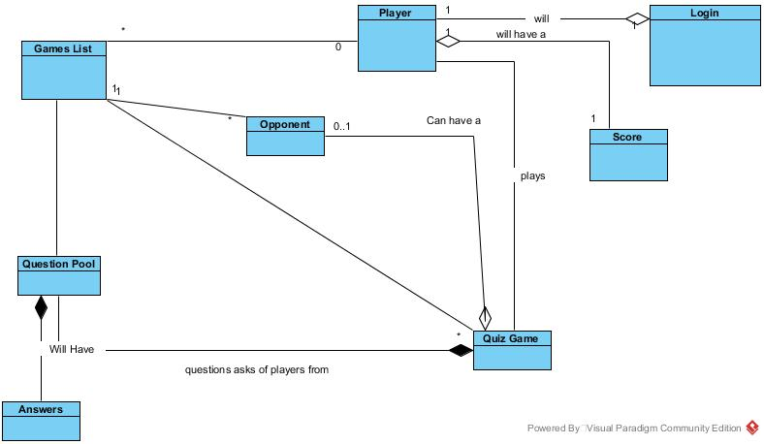

## Logical View

### Important Classes

The player class holds the name, email and login id for every user. A player can login, through the authentication services provided (Facebook or Let’s Quiz account) or they can skip and play as a guest. Once authenticated a player can play a quiz game. The quiz game here is the multiplayer quiz game. The functionality for a single player game will be slightly different as users will not require an internet connection.

The quiz game becomes part of the games list held on the MySQL database. During gameplay the Quiz game will request a question from the question pool. The current game status after every question will be sent to the MySQL database. The question pool also has a list of answers to all questions which will be made available at the end of the game to both players. The quiz game will create a score class to keep track of player score and high score data. Once a game is finished it is removed from the current games list on the database.

Users will require an internet connection for all updates to the database. This happens at the beginning of a game and at the beginning and end of any question. It is required at the beginning of a question in order to retrieve the result of the other player’s answer. It is required at the end in order to update the database with the player’s response to the question.

## Deployment Diagram

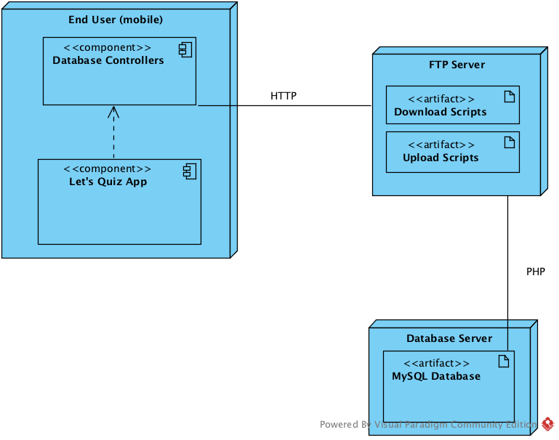

## Database ERD

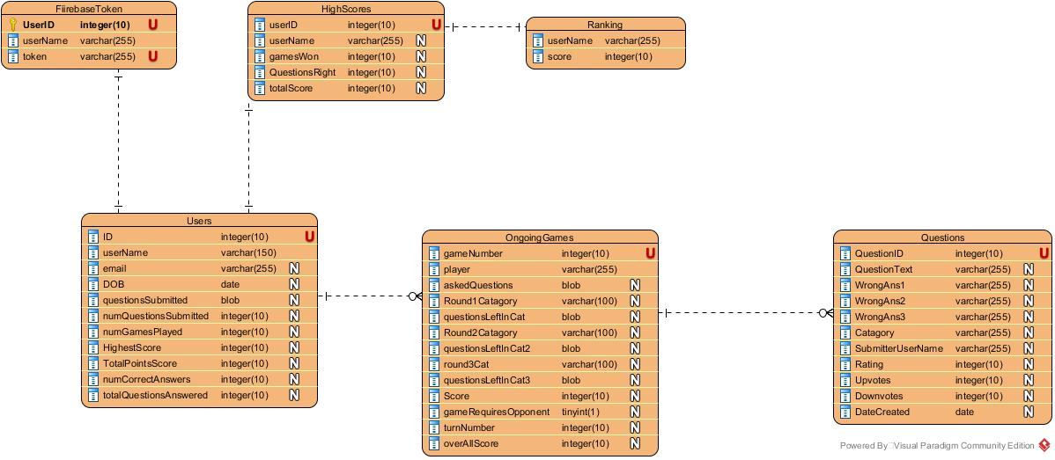

## Full Sequence Diagram

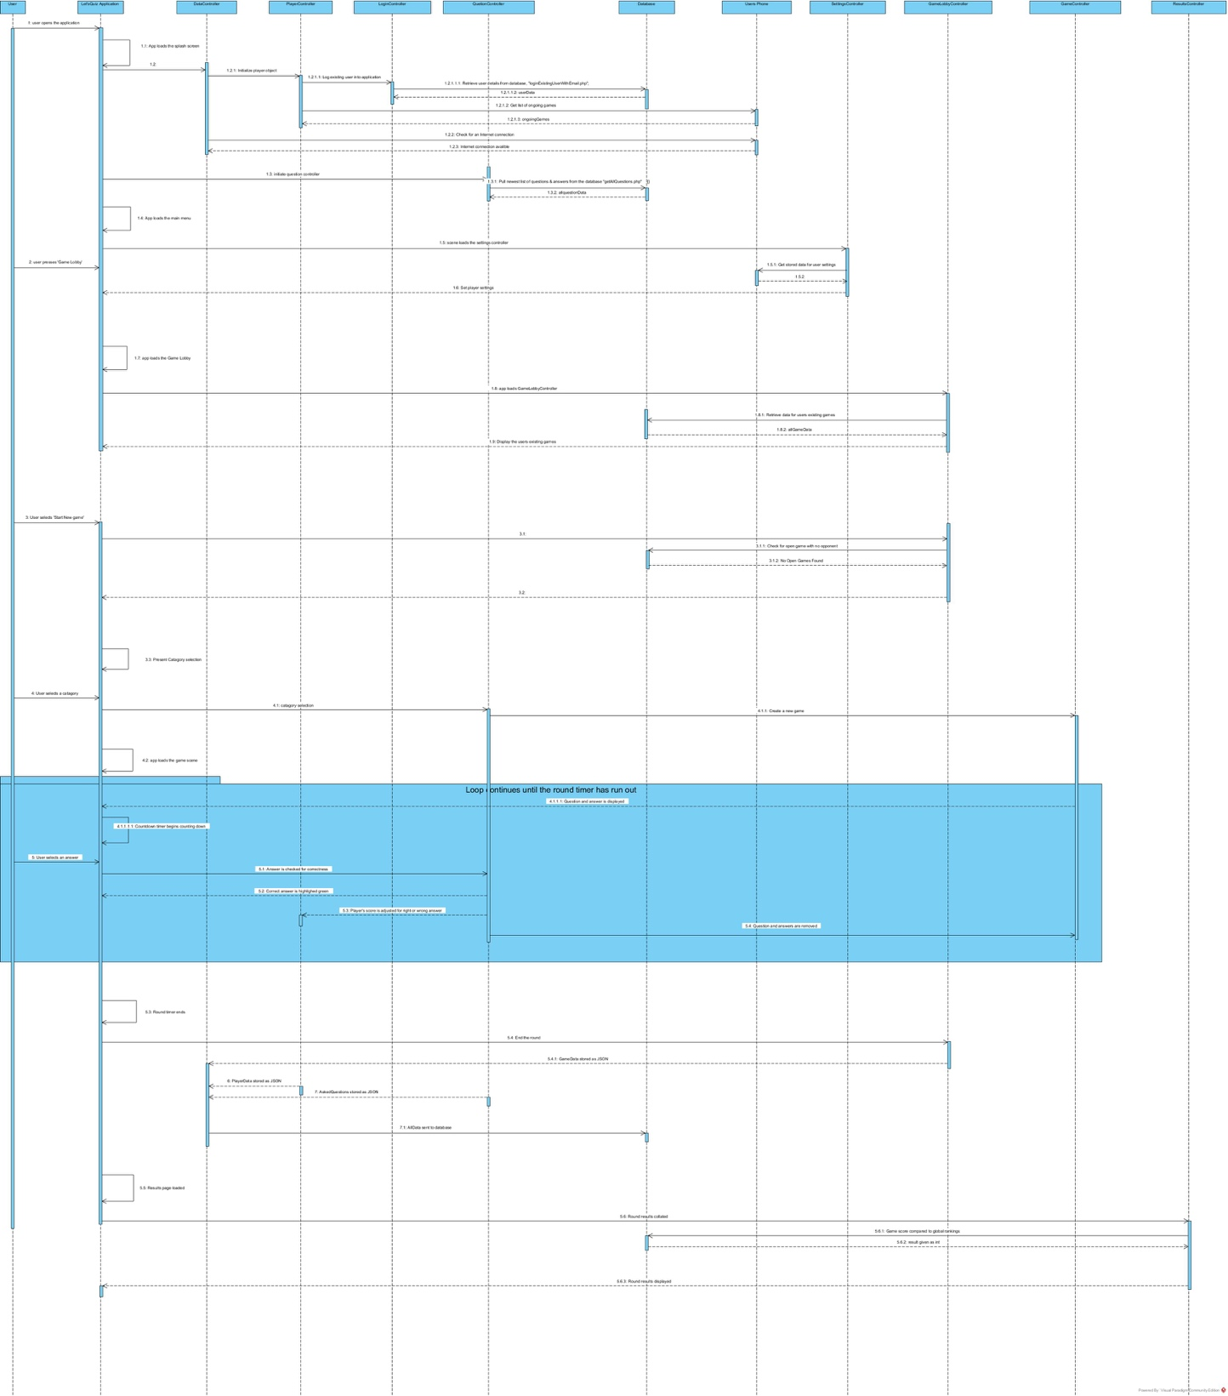

# Implementation of CCRD

## Implementation

As stated in the Initial Requirement Model, the CCRD use case involves the high-level items of Register, Login, Answer Question and Submit Score. These use cases cover all of the necessary architecture for the entire system to be realised.

### Register

Requires input fields for necessary information as well as buttons for submitting the data. The application must have a connection to the database in order to submit the information and register the new user. If no connection is available this will not be possible and time out. Registering will submit the given information into the relevant fields in the player table on the MySQL database. A unique identifier will also be created at this point for the new user. Once this is complete the user is given feedback that is was successful and is logged in.

### Login

Input fields are given to the user to authenticate themselves with a username/email and password. This will require a connection to the database. Once a connection is made the given information is compared to the fields in the player table and if a match is found the player is logged in a feedback given. If not, the player is notified that their supplied information is incorrect.

Once a player has logged in before they will automatically be logged in each time they open the app as their username and password is stored locally inside the app for quicker log in.

### Answer Question

All gameplay takes place inside the Game Controller. In order for a player to answer questions, firstly questions must be available for the player to answer.

When the player performs log in a connection to the database is established and all questions currently on the database are downloaded in a single JSON string. This string is stored inside the PlayerController, once this has been completed at least once offline gameplay is available.

When the player launches the game the QuestionController is called and serializes the JSON into useable QuestionData objects containing a question, 4 answers and whether they are correct or incorrect.

Before questions are shown they are randomised inside the question Pool array to ensure the player does not receive the same set of questions each time they Play Game. The order of answers is also randomised.

Inside the Game scene the player is presented with a UI containing the question Text and the four answers. When a user selects an answer the Game Controller determines if the selected answer is correct and changes the colour of the button, green or red, to reflect the response.

At this point the game score is also updated for correct and incorrect responses.

### Submit Score

Submit Score is required to update the players total accumulated score over all games as well as to compare between their opponent. When a round or game is finished the score is updated to the players accumulated score, a check is also made to see if this is a new high score for the player.

The game controller then establishes a connection to the database and updates the game table with the scores. Once the player and opponent’s data is received, a winner is determined and the mobile clients display the result.